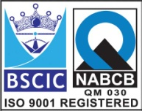****

**EASCO “Y” Type Strainer Screwed**

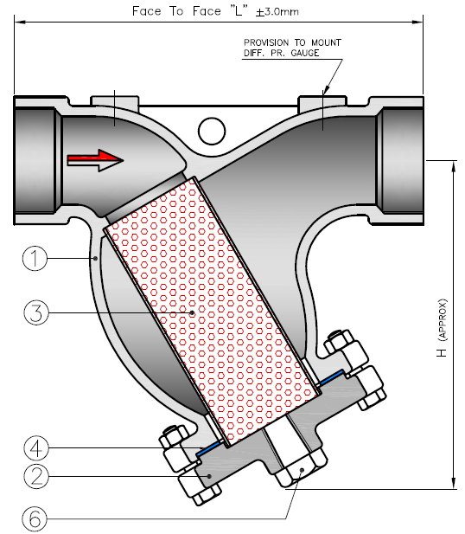

**Features: -**

* Pressure Rating: 150#
* Screwed : As Per ANSI B 16.11
* Socket Weld : As Per ANSI B 16.11
* Face to Face : Manufacturing Std.

**Testing Standard: API 598**

|  |  |
| --- | --- |
| Test Pressure in PSIG | |
| Test | Hydrostatic  ASA150# |
| Pr. Rating |
| Body | 425 |

**Part List: - Standard Dimension (150#): - ASME B 16.34**

|  |  |  |  |  |  |  |  |  |  |  |  |
| --- | --- | --- | --- | --- | --- | --- | --- | --- | --- | --- | --- |
| **No.** | **Part Name** | **Materials** |  | **Size** | **15** | **20** | **25** | **40** | **50** | **65** | **80** |
| **01** | Body | A216 Gr. WCB / Cast Iron /  ASTM A 351 Gr. CF8 / CF8M |  | **L** | 160 | 160 | 160 | 200 | 230 | 290 | 310 |
| **02** | Cover |  | **H** | 130 | 130 | 130 | 190 | 205 | 275 | 300 |
| **03** | Mesh | SS 304 / 316 |  |  |  |  |  |  |  |  |  |
|  |  |  |  |  |  |  |  |  |
| **04** | Gasket | CAF / Graphite Asbestos / Sp.Wound |  |  |  |  |  |  |  |  |  |
| **05** | Cover Bolt & Nut | CS / B7 / 2H / SS 304 / 316 |  |  |  |  |  |  |  |  |  |
| **06** | Drain Plug | CS / SS 304/ 316 |  |  |  |  |  |  |  |  |  |
|  |  |  |  |  |  |  |  |  |  |  |  |
|  |  |  |  |  |  |  |  |  |  |  |  |
|  |  |  |  |  |  |  |  |  |  |  |  |

**Due to continuous development Program, the design & data given in this leaflet are subject to change without prior notice.**

**ANITA ENGINEERING WORKS**



58-59, Narayan Estate, Opp. Shree Ram Estate, Nr. CMC Ltd. Odhav, Ahmedabad-382415, Gujarat, India

Phone: +91 79 22974101, Fax: +91 79 22875014

Email: eascovalves@gmail.com, eascovalves@yahoo.com, Web: [www.eascovalve.com](http://www.eascovalve.com)